**Sprint 2 – Accuracy Design Document**

**April 06, 2023**

**McKayla Miksza and Julia Buck**

**Table of Contents**

**1.** **EXECUTIVE SUMMARY 3**

1.1 Project Overview 3

1.2 Purpose and Scope of this Specification 3

**2.** **PRODUCT/SERVICE DESCRIPTION 3**

2.1 Product Context 3

2.2 User Characteristics 3

2.3 Assumptions 3

2.4 Constraints 3

2.5 Dependencies 4

**3.** **REQUIREMENTS 4**

3.1 Functional Requirements 5

3.2 Security 5

*3.2.1* *Protection 5*

*3.2.2* *Authorization and Authentication 6*

3.3 Portability 6

**4.** **REQUIREMENTS CONFIRMATION/STAKEHOLDER SIGN-OFF 6**

**5.** **SYSTEM DESIGN 6**

5.1 Algorithm 6

5.2 System Flow 6

5.3 Software 6

5.4 Hardware 6

5.5 Test Plan 7

5.6 Task List/Gantt Chart 7

5.7 Staffing Plan 7

# Executive Summary

## ***Project Overview***

Project Sprint 2 - Accuracy, is a project designed to allow the team members to create an application and later apply it to a robot that will allow it to follow the course set in advance. The intended audience of this project is Professor Eckert and class.

## ***Purpose and Scope of this Specification***

The primary objective of this project is to utilize a particular software to develop a highly functional application. This application will subsequently be integrated with a specific hardware system, which will facilitate a demonstration of its capabilities.

**In scope**

* The given robot must complete the course outlined
* Completion must include the avoidance of any objects that may be present
* The LED colors of the robot must change
* The lines must be spoken at the beginning and the end of the course
* The robot is able to stay at the center of each line segment of the course

**Out of Scope**

* The robot can stop at the center of the square

# Product/Service Description

The general factors that will affect the product and its requirements are the accessibility of the software provided to the team members as well as the capabilities of the robot. Each requirement is crucial to the application, however, there is an order to be followed due to the dependency on the previous requirement.

## ***Product Context***

This product interfaces with a variety of systems like it because to succeed at the job it needs to do it has to connect with the robot which is a system.

## ***User Characteristics***

Julia Buck: Advanced Beginner with prior use of the system and product; Software engineering major

McKayla Miksza: Has prior knowledge of the system, Advanced Beginner with experience in the system and product; Math Major

Dr. Eckert: Professional; Professor

## ***Assumptions***

The assumption of the availability of the testing room affects the requirements because the ability to test each requirement accurately on the outlined course is important to the testing process. The availability of the software is equally as critical, specifically the connection and control over the robotic hardware. If the software were to be unavailable the robot will not be able to receive the instructions and follow the given path, one of the most important requirements.

## ***Constraints***

Constraints of the design options will be the layout of the course as well as the positions of any obstacles that could possibly impact the robot’s run of the track. Obstacles may include the walls and furniture around the confined space.

## ***Dependencies***

The robot needs to be turned on, charged as well as connected for any of the requirements to function. For requirements 4 to work, requirement 3 will have to be the correct length and speed for the track.

# Requirements

For this project to be functional and efficient the requirements must be discussed and laid out in a proper way.

According to the prompt the objective of the robot application is to travel the taped outline set in advance around the floor of Howard Hall room 208.

**PIORITY 1 (“MUST HAVE”) REQUIREMENTS:**

1. There should be no issue of obstacles preventing the robot from completing this task.
2. The initial point will be in the square provided on the path, designated by the tape.
3. The robot shall then proceed to complete the course, consisting of a figure eight to be looped a total of five times
4. At the completion of the course, the LED light in the robot should flash multicolored lights for five seconds and speak the line provided in the prompt.
5. Never stray from each line segment of the course
6. Each team member should participate in the totality of the project, however, are allowed to split responsibilities to produce a better final product.

**PRIORITY 2 REQUIREMENTS:**

1. The blocks included in the code to roll the robot should include proportionate speed and timing to the course outline.
2. Between each of the rolls along the outline the robot should delay to allow the system to process the following commands.

**PRIORITY 3 (“NICE TO HAVE”) REQUIREMENTS:**

1. The block code is able to be precise in the rolls of the robot
   1. Stop directly at the intersection between tape segments
   2. Stop directly at the intersection when complete with the course
   3. Turn in the initial direction when the application completes the course entirely.

## ***Functional Requirements***

| **Req#** | **Requirement** | **Comments** | **Priority** | **Date Rvwd** | **SME Reviewed / Approved** |
| --- | --- | --- | --- | --- | --- |
| ACCUR_01 | Start run in the square provided | Reviewed and agreed | High | 03-29-23 | Approved |
| ACCUR _02 | Loop the figue eight 5 times | Reviewed and agreed | High | 03-29-23 | Approved |
| ACCUR _03 | Finish run in the initial square provided | Reviewed and agreed | High | 03-29-23 | Approved |
| ACCUR _04 | Speak “I am the Winner” at completion | Reviewed and agreed | High | 03-29-23 | Approved |
| ACCUR _05 | Flash multicolored lights for 5 seconds at completion | Discussed and reviewed | High | 03-29-23 | Approved |
| ACCUR _06 | Not collide with any objects | Agreed and discussed prevention techniques | High | 03-29-23 | Approved |
| ACCUR _07 | Not stray from the path given | Agreed and discussed prevention techniques | High | 03-29-23 | Approved |

## ***Security***

### **Protection**

The factors that will protect the system are encryption because the only people who have access to Sphero Edu will be able to understand and interpret the code used for this project. Activity logging will be another protection factor due to its ability to aid the team members in identifying patterns and possible issues with the project. Activity logging also gives the team members the ability to work backwards to fix the issues that may be present. System protection is also provided by data integrity checks. Without these the team members would be unable to correctly determine where the issue lies within the system. The data integrity checks will allow the team members to take the project step by step and ensure that the application is correctly being applied.

### **Authorization and Authentication**

The robot should be connected the application used to supply the robot with iintrsuctions.

## ***Portability***

The dependability of the project is dependable due to its accessibility on all of the team member’s hardware and easily reported to other databases. For example, screenshots taken of the code and the product data were attached to the repository created fro this project and further linked to the dropbox provided on eCampus by the Dr. Eckert.

# Requirements Confirmation/Stakeholder sign-off

| **Meeting Date** | **Attendees (name and role)** | **Comments** |
| --- | --- | --- |
| 03/29/2023 | Julia Buck, McKayla Miksza | Confirmed all |

# System Design

This section will provide all details concerning the technical design, staffing, coding, and testing the system

## ***Algorithm***

1. Set **count** to 0
2. Set speed to 67
3. Set spin to 360 degrees at 9 seconds
4. Set spin to -360 degrees at 9 seconds
5. If count is less than 5 repeat steps two to four
6. Speak “I am the winner”
7. Set mail LED to fade from red to yellow to blue to green to red to purple

## ***System Flow***

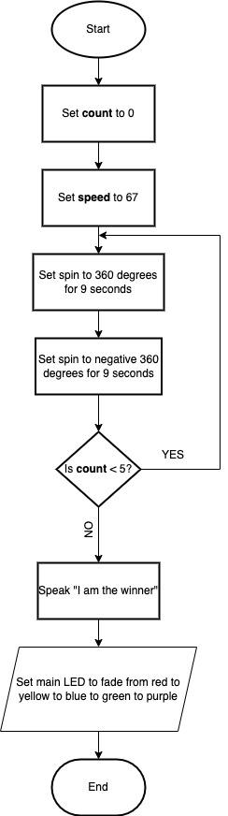

**Block Code**

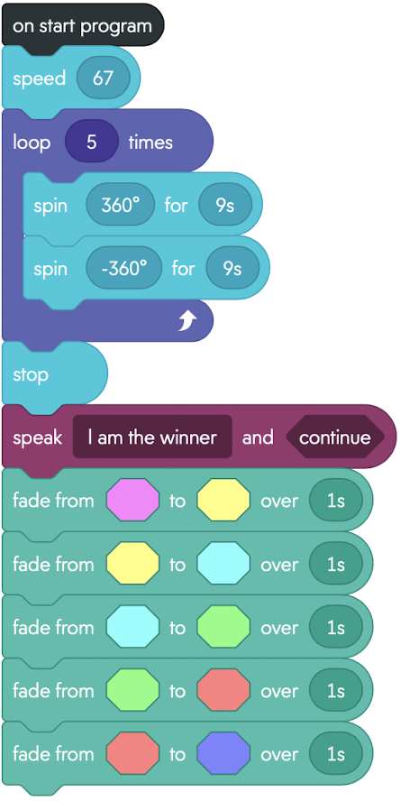

**Sensor Data**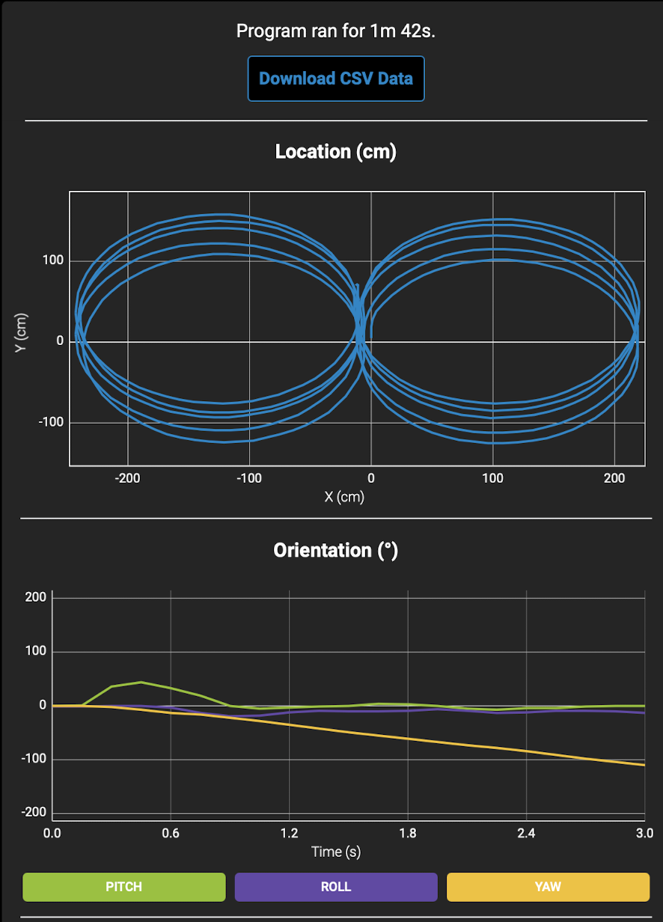

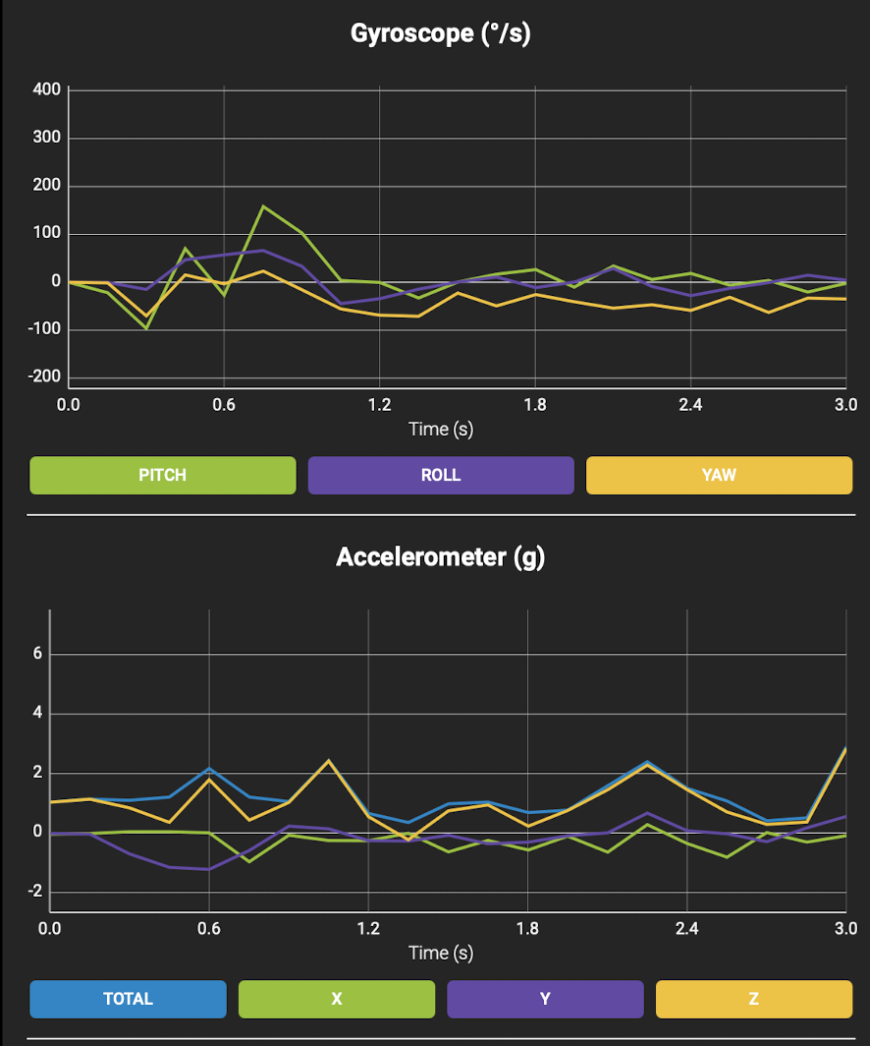

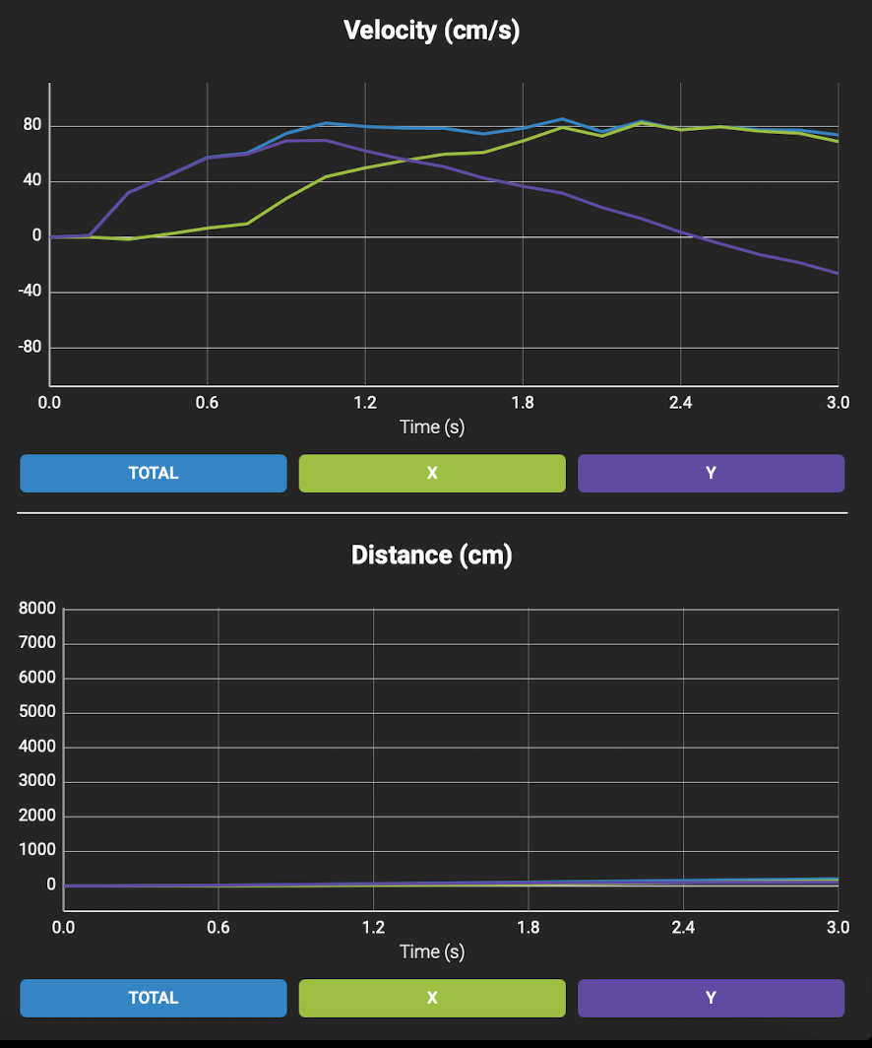

## ***Software***

This application was developed and tested on Sphero Edu, using block code to deploy the application.

## ***Hardware***

To develop, test, and demonstrate this application, the team members used different hardware platforms. These included 2 MacBook Laptops (one from each team member), which helped in the development of the application on the software Sphero Edu; the Sphero SPRK Coding Robot, which was used to test and demonstrate this application on the course outlined on the floor; the charger of the Sphero SPRK Coding Robot, which helped keep the robot powered for the testing process as well as the demonstration.

## ***Test Plan***

| **Reason for Test Case** | **Test Date** | **Expected Output** | **Observed Output** | **Staff Name** | **Pass/Fail** |
| --- | --- | --- | --- | --- | --- |
| Requirement Number(s):  ACCUR_01 | 04-03-23 | Start the run in square given |  | Julia Buck | PASS |
| Requirement Number(s):  ACCUR _02 | 04-03-23 | Loop the figure eight 5 times | Looped the figure eight five times but would shift after each loop | McKayla Miksza | PASS |
| Requirement Number(s):  ACCUR _03 | 04-03-23 | Finishes run in the square given |  | Julia Buck | PASS |
| Requirement Number(s):  ACCUR _04 | 04-03-23 | Speaks “I am the winner” |  | McKayla Miksza | PASS |
| Requirement Number(s):  ACCUR _05 | 04-03-23 | Flashes multicolored lights for 5 seconds |  | Julia Buck | PASS |
| Requirement Number(s):  ACCUR _06 | 04-03-23 | Does not collide with any objects | Would collide with the table and chairs surrounding because of shifting | McKayla Miksza | FAIL |
| Requirement Number(s):  ACCUR _06 | 04-03-23 | Does not collide with any objects | Would collide with the table and chairs surrounding because of shifting | McKayla Miksza | FAIL |
| Requirement Number(s):  ACCUR _06 | 04-03-23 | Does not collide with any objects | Still shifted slightly but no collision | McKayla Miksza | PASS |
| Requirement Number(s):  ACCUR _07 | 04-03-23 | Does not stray from the path given | Continuous shifting | Julia Buck | FAIL |
| Requirement Number(s):  ACCUR _07 | 04-03-23 | Does not stray from the path given | Continuous shifting | Julia Buck | FAIL |
| Requirement Number(s):  ACCUR _07 | 04-03-23 | Does not stray from the path given | Contiued to shift but stayed on path at times. | Julia Buck | PASS |

## ***Task List/Gantt Chart***

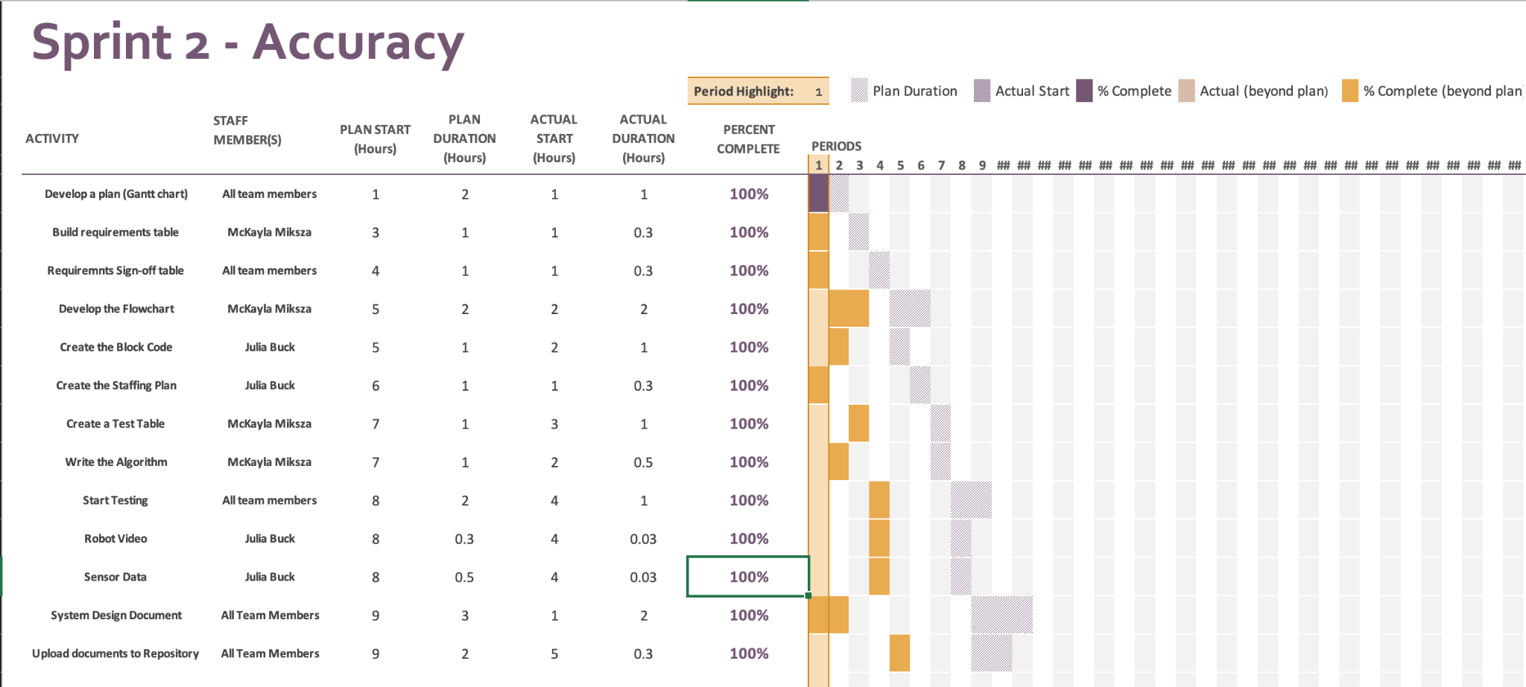

## ***Staffing Plan***

| Name | Role | Responsibility | Reports To |
| --- | --- | --- | --- |
| McKayla Miksza | Team Member | Develop a Plan (Gantt Chart)  Build a Requirements Table  Requirements Sign-off Table.  Build a Flowchart  Create a Test Table  Create the Algorithm  Testing Process  System Design Document  Upload documents to Repository | Julia Buck |
| Julia Buck | Team Member | Develop a Plan (Gantt Chart)  Requirements Sing-off Table.  Create the Block Code  Create the Staffing Plan  Testing Process  Take Robot Course Completion Video  Take Screenshot of Sensor Data  System Design Document  Upload Documents/Video to Repository | McKayla Miksza |